**Classical Mechanics**

**Commonly Used Constants**

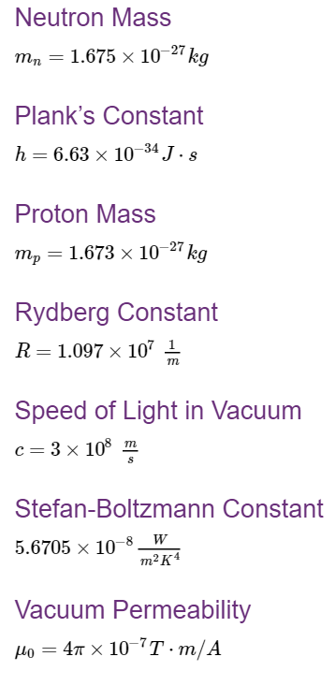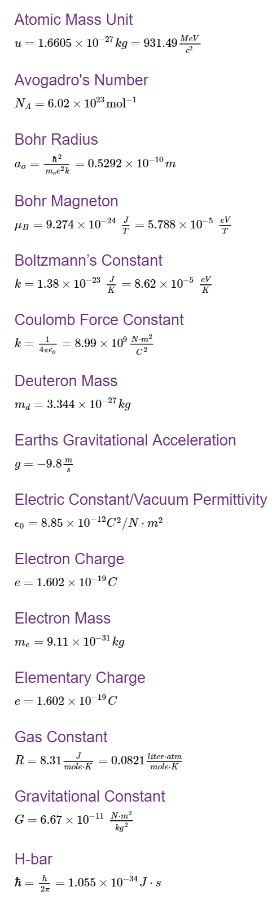

|  |  |
| --- | --- |
| **Topic** | Classical Mechanics |
| **Subtopic** | Unit Conversion |
| **Concept Name** | Units |
| **Description** | Mechanics is the branch of physics in which units are derived. A given quantity can be represented in different units to depict the same amount. This is especially useful when working on a physics problem that involves multiple units. |
| **Formula** | N/A |
| **Drawing/Animation** | N/A |
| **Relevant Tags** | Units, quantity, multiple |

|  |  |
| --- | --- |
| **Topic** | Classical Mechanics |
| **Subtopic** | Unit Conversion |
| **Concept Name** | Units |
| **Description** | Mechanics is the branch of physics in which units are derived. A given quantity can be represented in different units to depict the same amount. This is especially useful when working on a physics problem that involves multiple units. |
| **Formula** | N/A |
| **Drawing/Animation** | N/A |
| **Relevant Tags** | Units, quantity, multiple, fractions |

|  |  |
| --- | --- |
| **Topic** | Classical Mechanics |
| **Subtopic** | Unit Conversion |
| **Concept Name** | Conversion Ratio |
| **Description** | Conversion ratios are fractions used to relate the magnitude of two units. A certain amount of one unit is in the numerator, and the equivalent amount of the other unit is in the denominator. For example:  The numerator and denominator of the conversion ratio can be multiplied by any number without changing the ratio. For example, if 1 minute is multiplied by 10, it is equal to 10 minutes divided by 600 seconds. Therefore, to convert between two units it is often useful to use ratio rules. |
| **Formula** | (1 min / 60 s) = (60 s / 1 min) = 1 |
| **Drawing/Animation** | N/A |
| **Relevant Tags** | Units, quantity, multiple, fractions |

|  |  |
| --- | --- |
| **Topic** | Classical Mechanics |
| **Subtopic** | Unit Conversion |
| **Concept Name** | Converting Units |
| **Description** | Converting between units can be done with a conversion ratio. To convert between units, you must multiply your quantity by the conversion ratio in a such a way that the original unit cancels out.  In this example, we are converting 1 min to hours: $$1 min*\frac{1 Hour }{60 min}=\frac{1}{60}hours=0.0167 hours$$ If a quantity has multiple units, a conversion ratio can convert one or more of them.  In this example, we are converting 32.7 kilogram•meters/second to kilogram•meters/minute. |
| **Formula** | $$32.7\frac{kg.m}{sec} *\frac{60sec}{1min}=1962 kg.m/min$$ $$1 min*\frac{1 Hour }{60 min}=\frac{1}{60}hours=0.0167 hours$$ |
| **Drawing/Animation** | N/A |
| **Relevant Tags** | Units, quantity, multiple, fractions, converting |

|  |  |
| --- | --- |
| **Topic** | Classical Mechanics |
| **Subtopic** | Free Body Diagrams |
| **Concept Name** |  |
| **Description** | **Free body diagrams** are used to summarize all forces acting on an object.   * **Object:** drawn as rectangle or square in center of diagram * **Forces:** Arrows stretch outwards from the object (can be push or pull) * **Magnitude:** Represented by length of arrows * **Direction:** Represented by direction of arrows |
| **Formula** | N/A |
| **Drawing/Animation** |  |
| **Relevant Tags** | Free, body, diagram, force, net, applied, gravitational, magnitude, direction, object |

|  |  |
| --- | --- |
| **Topic** | Classical Mechanics |
| **Subtopic** | Vectors |
| **Concept Name** | Definition |
| **Description** | **Vectors**: Have both a magnitude and direction (example: velocity of 15 m/s east)   * Vectors are typically written in boldface**a**, or a letter with an arrow above it a⃗. * Vectors can be represented by an arrow (**magnitude** = length of arrow, **direction** = direction of arrow)   **Scalars**: Have magnitude only (example: speed of 15 m/s)  **Other common examples of vectors**:   * Force, momentum, acceleration, angular momentum, magnetic fields and electric fields |
| **Formula** | N/A |
| **Drawing/Animation** | N/A |
| **Relevant Tags** | Vector, boldface, magnitude, direction, force, net, scalars, quantity |

|  |  |
| --- | --- |
| **Topic** | Classical Mechanics |
| **Subtopic** | Vectors |
| **Concept Name** | Components of a vector in 2D Form |
| **Description** | Any vector can be written as a sum of a set of orthogonal vectors. This allows us to define the components of the vector.  **2D Form of a vector**a⃗ =(x,y)  The components x and y of the vector can be expressed using the magnitude and angle, θ as:  The components can be arranged in a column to represent the vector***.*** |
| **Formula** | x=|a⃗ |cos(θ)  y=|a⃗ |sin(θ)  a⃗ =[x y] |
| **Drawing/Animation** |  |
| **Relevant Tags** | Vector, boldface, magnitude, direction, force, net, scalars, quantity |

|  |  |
| --- | --- |
| **Topic** | Classical Mechanics |
| **Subtopic** | Vectors |
| **Concept Name** | Magnitude of a Vector in 2D |
| **Description** | **Magnitude of a⃗** (diagram above) is denoted with absolute bars **|a⃗ |** and is found using Pythagorean theorem, sqrt(x2 + y2)  Let e⃗x  be a vector of magnitude 1 pointing along the x axis, and e⃗ y be a vector of magnitude 1 pointing along the y axis. Then the vector a⃗ can be written as:  a⃗ =xe⃗x+ye⃗y |
| **Formula** | a⃗ =xe⃗x+ye⃗y  sqrt(x2 + y2) |
| **Drawing/Animation** | N/A |
| **Relevant Tags** | Vector, boldface, magnitude, direction, force, net, scalars, quantity |

|  |  |
| --- | --- |
| **Topic** | Classical Mechanics |
| **Subtopic** | Vectors |
| **Concept Name** | Components of a vector in 3D Form |
| **Description** | **3D Form for the vector**b⃗ =(x,y,z)**:**  z  b  x  y  **The components x, y and z of the vector can be expressed using the magnitude, and angles, α, β, and γ as:**  x=|b⃗ |cosα  y=|b⃗ |cosβ  z=|b⃗ |cosγ  The components can also be arranged in column form to represent the vector***.***b⃗ = [x y z] |
| **Formula** | x=|b⃗ |cosα  y=|b⃗ |cosβ  z=|b⃗ |cosγ  b⃗ = [x y z] |
| **Drawing/Animation** |  |
| **Relevant Tags** | Vector, boldface, magnitude, direction, force, net, scalars, quantity |

|  |  |
| --- | --- |
| **Topic** | Classical Mechanics |
| **Subtopic** | Vectors |
| **Concept Name** | Magnitude of a vector in 3D |
| **Description** | **Magnitude of b⃗** (diagram above) is denoted with absolute bars  **|b⃗ |**and is found using Pythagorean theorem twice, once for each of the two triangles.  Let e⃗ x be a vector of magnitude 1 pointing along the x axis, e⃗ y be a vector of magnitude 1 pointing along the y axis, and e⃗ z be a vector of magnitude 1 pointing along the z axis. Then the vector b⃗ can be written as:  b⃗ =xe⃗ x + ye⃗ y + ze⃗ |
| **Formula** | b⃗ =xe⃗ x + ye⃗ y + ze⃗ |
| **Drawing/Animation** | N/A |
| **Relevant Tags** | Vector, boldface, magnitude, direction, force, net, scalars, quantity, 3D, 2D, Addition, Subtraction |

|  |  |
| --- | --- |
| **Topic** | Classical Mechanics |
| **Subtopic** | Vectors |
| **Concept Name** | Addition and Subtraction |
| **Description** | Two or more vectors can be added. The sum of vectors (or resultant vectors) can be found geometrically. This is found by arranging vectors head to tail, and connecting the tail of the first vector to the head of the last vector.  a  b  c  c⃗ =a⃗ + b⃗  The sum of vectors may also be found by adding the components of the vectors.  Let a⃗ =x1e⃗ x+y1e⃗ y+z1e⃗ z and b⃗ =x2e⃗ x+y2e⃗ y+z2e⃗ z  Therefore: c⃗ =(x1+x2)e⃗ x + (y1+y2)e⃗ y + (z1+z2)e⃗ z  The sum of vectors may also be found by vector column addition.  Subtracting vectors is similar to adding vectors. A vector that is equal in magnitude to b⃗ , but opposite in direction is written as −b⃗ .  The difference between two vectors can be found using:  c⃗ =a⃗ + (−b⃗ ) |
| **Formula** | c⃗ =a⃗ + (−b⃗ )  c⃗ =(x1+x2)e⃗ x + (y1+y2)e⃗ y + (z1+z2)e⃗ z  a⃗ =x1e⃗ x+y1e⃗ y+z1e⃗ z and b⃗ =x2e⃗ x+y2e⃗ y+z2e⃗ z |
| **Drawing/Animation** |  |
| **Relevant Tags** | Vector, boldface, magnitude, direction, force, net, scalars, quantity, 3D, 2D, Addition, Subtraction |

|  |  |
| --- | --- |
| **Topic** | Classical Mechanics |
| **Subtopic** | Vectors |
| **Concept Name** | Dot Product (Scalar Product) |
| **Description** | The dot product of vectors is often considered as the multiplication of two vectors. It is defined to be:  and can also be found using components:  If **a⃗ ⋅b⃗ =0**, and we know that a⃗ ≠0 and b⃗ ≠0 it then tells us that cosθ=0:   * Therefore, θ=90∘, 270∘ and a⃗ and b⃗ are both **orthogonal** vectors.   An example of when the dot product is used in physics is for calculating work: |
| **Formula** |  |
| **Drawing/Animation** | N/A |
| **Relevant Tags** | Vector, boldface, magnitude, direction, force, net, scalars, quantity, 3D, 2D, Addition, Subtraction, dot product |

|  |  |
| --- | --- |
| **Topic** | Classical Mechanics |
| **Subtopic** | Vectors |
| **Concept Name** | Magnitude of a vector in 3D |
| **Description** | **Magnitude of b⃗** (diagram above) is denoted with absolute bars  **|b⃗ |**and is found using Pythagorean theorem twice, once for each of the two triangles.  Let e⃗ x be a vector of magnitude 1 pointing along the x axis, e⃗ y be a vector of magnitude 1 pointing along the y axis, and e⃗ z be a vector of magnitude 1 pointing along the z axis. Then the vector b⃗ can be written as:  b⃗ =xe⃗ x + ye⃗ y + ze⃗ |
| **Formula** | b⃗ =xe⃗ x + ye⃗ y + ze⃗ |
| **Drawing/Animation** | N/A |
| **Relevant Tags** | Vector, boldface, magnitude, direction, force, net, scalars, quantity, 3D, 2D, Addition, Subtraction |